COURT INTELLIGENCE MANAGEMENT SYSTEM
ENTITY RELATIONSHIP DIAGRAM REVISI
Logical Data Model untuk Compliance MVP, Scheduling, dan Virtual Hearing

Kode Dokumen | CIMS-ERD-003/2026
Versi | 2.1
Status | Development Baseline
Tanggal | Juli 2026
Dokumen ini diturunkan dari SOP Persidangan Pidana Elektronik CIMS Revisi 2026, PKS lintas instansi, SEMA Nomor 2 Tahun 2026, dan Matriks Penyesuaian MVP CIMS.

Pengendalian Dokumen
Tahap | Penanggung Jawab | Paraf atau Tanggal
Disusun oleh | System Analyst dan Data Architect CIMS | Tanggal: __________
Diverifikasi proses bisnis | Perwakilan Pengadilan, Kejaksaan, dan Pemasyarakatan | Tanggal: __________
Diverifikasi hukum | Unit hukum masing-masing instansi | Tanggal: __________
Diverifikasi keamanan | Pejabat atau Tim Keamanan Informasi | Tanggal: __________
Disetujui | Product Owner dan pejabat berwenang lintas instansi | Tanggal: __________

Status baseline
Dokumen menjadi acuan desain dan pengembangan setelah memperoleh persetujuan lintas instansi. Perubahan terhadap alur kewenangan, data sensitif, rekaman, atau AI wajib melalui change control.

1. Prinsip Data Model
- Reference-first. CIMS menyimpan official system reference dan tidak menjadi register hukum tandingan.
- Authority-aware. Data akses mempertimbangkan role, organisasi, unit, perkara, dan delegasi.
- Evidence-oriented. Notice, acknowledgment, readiness, incident, dan privileged action mempunyai bukti.
- Versioned. Schedule, determination reference, notice, dan configuration mempertahankan riwayat.
- Append-only audit. Audit log tidak dapat diubah pengguna biasa.
- Privacy by design. Data identitas diminimalkan dan biometrik dinonaktifkan secara default.
- Provider-agnostic. Virtual session tidak bergantung pada tabel khusus Zoom.

2. ERD Konseptual
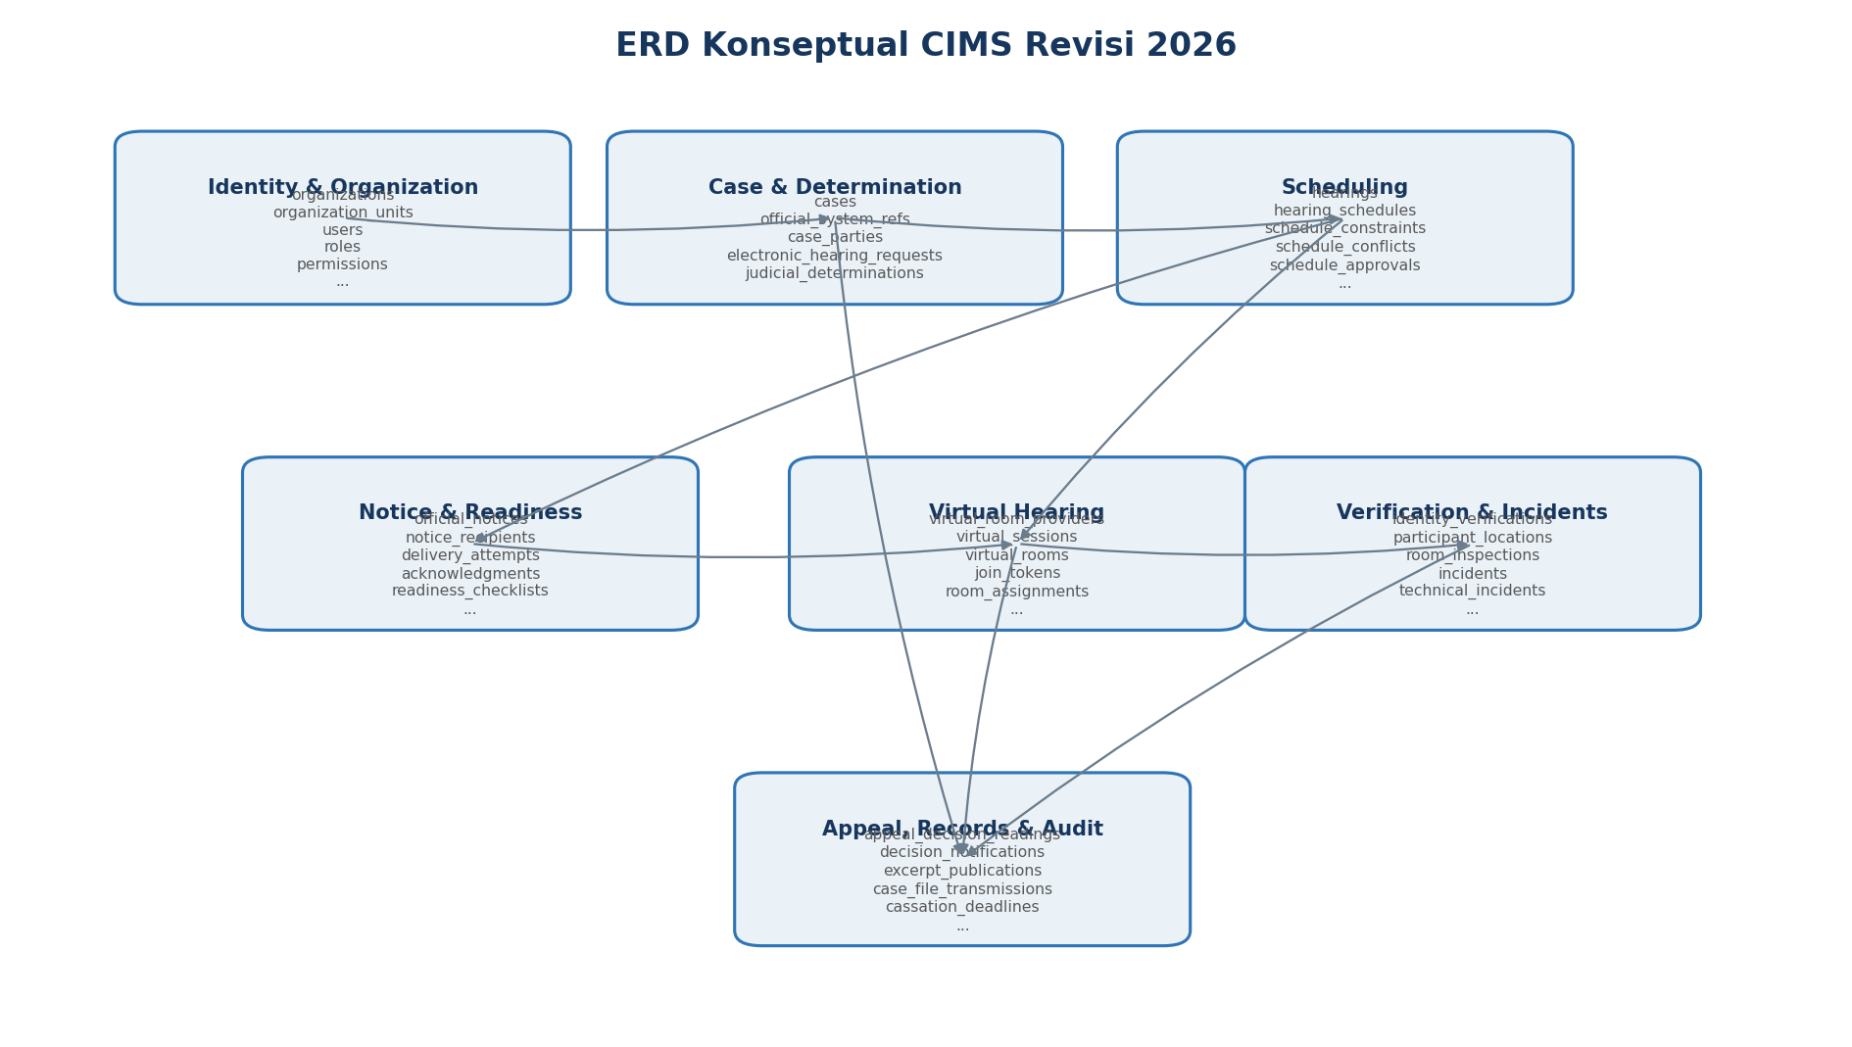
Gambar 1. Hubungan tujuh domain utama CIMS.

3. Bounded Context dan Entitas
Domain | Entitas
Identity & Organization | organizations, organization_units, users, roles, permissions, user_roles, delegations, liaison_officers
Case & Determination | cases, official_system_refs, case_parties, electronic_hearing_requests, judicial_determinations
Scheduling | hearings, hearing_schedules, schedule_constraints, schedule_conflicts, schedule_approvals, reschedules
Notice & Readiness | official_notices, notice_recipients, delivery_attempts, acknowledgments, readiness_checklists, readiness_items, technical_tests
Virtual Hearing | virtual_room_providers, virtual_sessions, virtual_rooms, join_tokens, room_assignments, provider_events, attendance, hearing_events
Verification & Incidents | identity_verifications, participant_locations, room_inspections, incidents, technical_incidents, cyber_incidents, force_majeure_events, incident_notifications
Appeal, Records & Audit | appeal_decision_readings, decision_notifications, excerpt_publications, case_file_transmissions, cassation_deadlines, documents, document_hashes, recordings, retention_policies, audit_logs

4. ERD Detail Scheduling dan Virtual Hearing

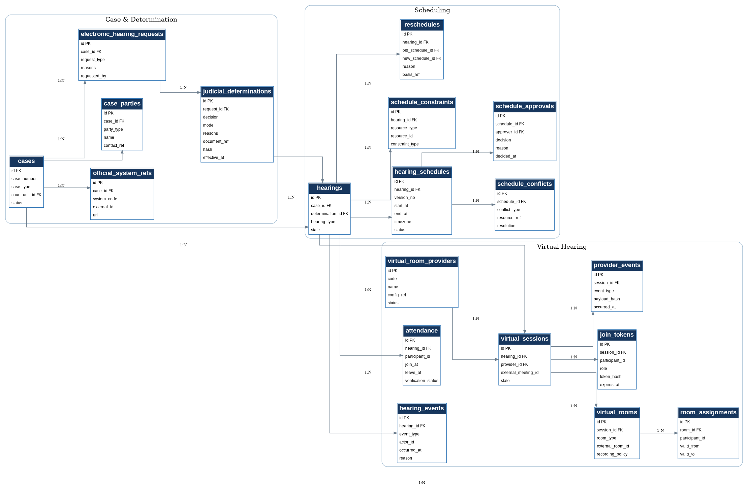
Gambar 2. Entitas determination, scheduling, dan virtual hearing.

5. ERD Detail Notice dan Readiness
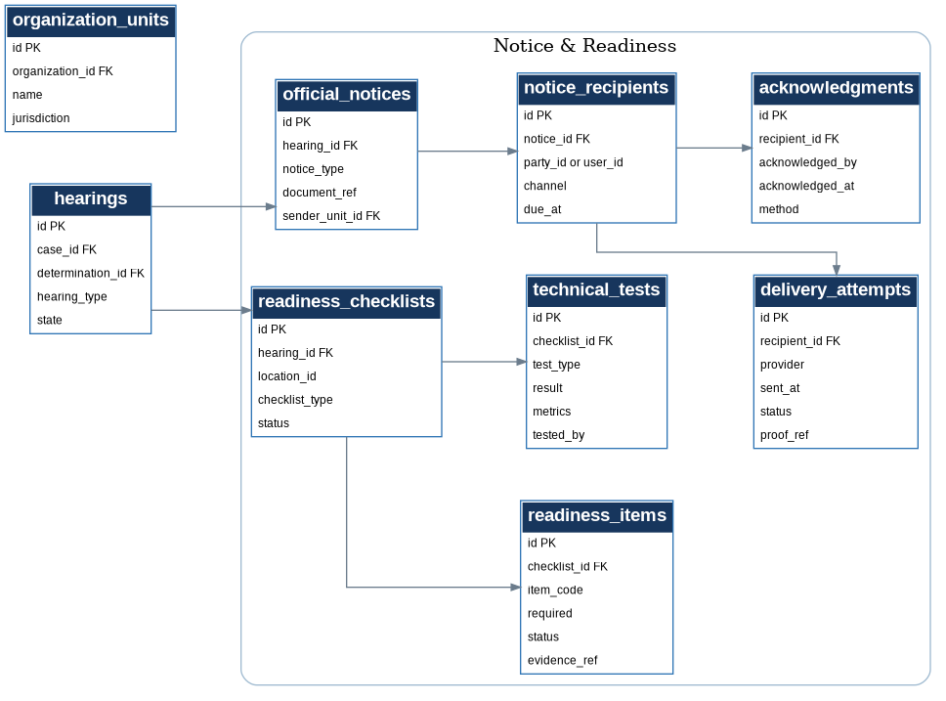
Gambar 3. Entitas pemberitahuan resmi, delivery, acknowledgment, checklist, dan uji teknis.

6. ERD Detail Verification dan Incident
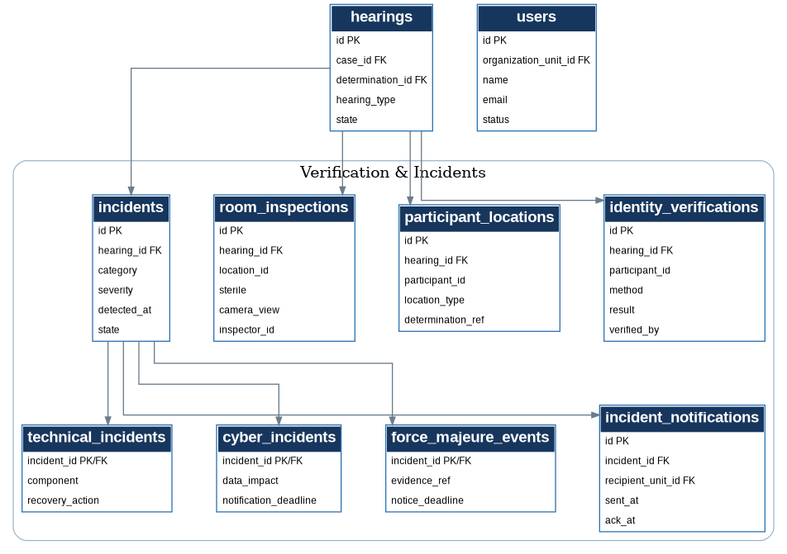
Gambar 4. Entitas identitas, lokasi, inspeksi ruang, technical incident, cyber incident, dan force majeure.

7. ERD Detail Appeal, Records, dan Audit
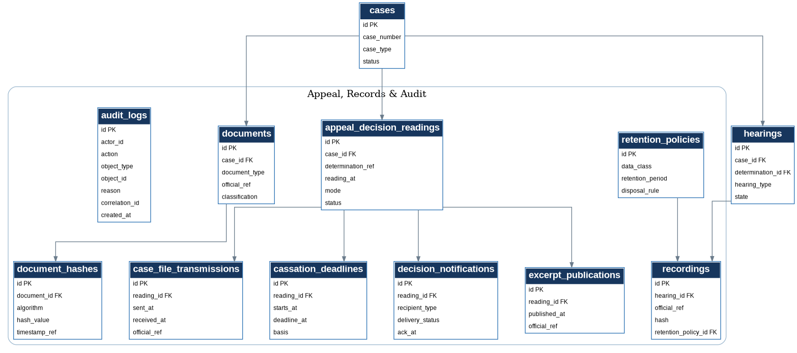
Gambar 5. Entitas pembacaan putusan banding, pemberitahuan, petikan, transmisi, deadline, records, dan audit.

8. Data Dictionary Ringkas
Domain | Entitas | Atribut Kunci
Identity & Organization | organizations | id PK, name, type, status
Identity & Organization | organization_units | id PK, organization_id FK, name, jurisdiction
Identity & Organization | users | id PK, organization_unit_id FK, name, email, status
Identity & Organization | roles | id PK, code, name
Identity & Organization | permissions | id PK, code, name
Identity & Organization | user_roles | user_id FK, role_id FK, valid_from, valid_to
Identity & Organization | delegations | id PK, grantor_user_id FK, grantee_user_id FK, scope, valid_to
Identity & Organization | liaison_officers | id PK, organization_unit_id FK, user_id FK, effective_dates
Case & Determination | cases | id PK, case_number, case_type, court_unit_id FK, status
Case & Determination | official_system_refs | id PK, case_id FK, system_code, external_id, url
Case & Determination | case_parties | id PK, case_id FK, party_type, name, contact_ref
Case & Determination | electronic_hearing_requests | id PK, case_id FK, request_type, reasons, requested_by
Case & Determination | judicial_determinations | id PK, request_id FK, decision, mode, reasons, document_ref, hash, effective_at
Scheduling | hearings | id PK, case_id FK, determination_id FK, hearing_type, state
Scheduling | hearing_schedules | id PK, hearing_id FK, version_no, start_at, end_at, timezone, status
Scheduling | schedule_constraints | id PK, hearing_id FK, resource_type, resource_id, constraint_type
Scheduling | schedule_conflicts | id PK, schedule_id FK, conflict_type, resource_ref, resolution
Scheduling | schedule_approvals | id PK, schedule_id FK, approver_id FK, decision, reason, decided_at
Scheduling | reschedules | id PK, hearing_id FK, old_schedule_id FK, new_schedule_id FK, reason, basis_ref
Notice & Readiness | official_notices | id PK, hearing_id FK, notice_type, document_ref, sender_unit_id FK
Notice & Readiness | notice_recipients | id PK, notice_id FK, party_id or user_id, channel, due_at
Notice & Readiness | delivery_attempts | id PK, recipient_id FK, provider, sent_at, status, proof_ref
Notice & Readiness | acknowledgments | id PK, recipient_id FK, acknowledged_by, acknowledged_at, method
Notice & Readiness | readiness_checklists | id PK, hearing_id FK, location_id, checklist_type, status
Notice & Readiness | readiness_items | id PK, checklist_id FK, item_code, required, status, evidence_ref
Notice & Readiness | technical_tests | id PK, checklist_id FK, test_type, result, metrics, tested_by
Virtual Hearing | virtual_room_providers | id PK, code, name, config_ref, status
Virtual Hearing | virtual_sessions | id PK, hearing_id FK, provider_id FK, external_meeting_id, state
Virtual Hearing | virtual_rooms | id PK, session_id FK, room_type, external_room_id, recording_policy
Virtual Hearing | join_tokens | id PK, session_id FK, participant_id, role, token_hash, expires_at
Virtual Hearing | room_assignments | id PK, room_id FK, participant_id, valid_from, valid_to
Virtual Hearing | provider_events | id PK, session_id FK, event_type, payload_hash, occurred_at
Virtual Hearing | attendance | id PK, hearing_id FK, participant_id, join_at, leave_at, verification_status
Virtual Hearing | hearing_events | id PK, hearing_id FK, event_type, actor_id, occurred_at, reason
Verification & Incidents | identity_verifications | id PK, hearing_id FK, participant_id, method, result, verified_by
Verification & Incidents | participant_locations | id PK, hearing_id FK, participant_id, location_type, determination_ref
Verification & Incidents | room_inspections | id PK, hearing_id FK, location_id, sterile, camera_view, inspector_id
Verification & Incidents | incidents | id PK, hearing_id FK, category, severity, detected_at, state
Verification & Incidents | technical_incidents | incident_id PK/FK, component, recovery_action
Verification & Incidents | cyber_incidents | incident_id PK/FK, data_impact, notification_deadline
Verification & Incidents | force_majeure_events | incident_id PK/FK, evidence_ref, notice_deadline
Verification & Incidents | incident_notifications | id PK, incident_id FK, recipient_unit_id FK, sent_at, ack_at
Appeal, Records & Audit | appeal_decision_readings | id PK, case_id FK, determination_ref, reading_at, mode, status
Appeal, Records & Audit | decision_notifications | id PK, reading_id FK, recipient_type, delivery_status, ack_at
Appeal, Records & Audit | excerpt_publications | id PK, reading_id FK, published_at, official_ref
Appeal, Records & Audit | case_file_transmissions | id PK, reading_id FK, sent_at, received_at, official_ref
Appeal, Records & Audit | cassation_deadlines | id PK, reading_id FK, starts_at, deadline_at, basis
Appeal, Records & Audit | documents | id PK, case_id FK, document_type, official_ref, classification
Appeal, Records & Audit | document_hashes | id PK, document_id FK, algorithm, hash_value, timestamp_ref
Appeal, Records & Audit | recordings | id PK, hearing_id FK, official_ref, hash, retention_policy_id FK
Appeal, Records & Audit | retention_policies | id PK, data_class, retention_period, disposal_rule
Appeal, Records & Audit | audit_logs | id PK, actor_id, action, object_type, object_id, reason, correlation_id, created_at

9. Detail Entitas Kritis Modul Jadwal
Entitas | Atribut Minimum | Fungsi
hearings | id, case_id, determination_id, hearing_type, state, current_schedule_id, created_at | Satu agenda persidangan dan state machine utama.
hearing_schedules | id, hearing_id, version_no, start_at, end_at, timezone, status, created_by | Versi jadwal. Status DRAFT, PROPOSED, ACTIVE, SUPERSEDED, CANCELLED.
schedule_constraints | id, hearing_id, resource_type, resource_id, constraint_type, required | Constraint hakim, jaksa, ruang, lokasi terdakwa, saksi, ahli, petugas, dan provider.
schedule_conflicts | id, schedule_id, conflict_type, resource_ref, details, resolution | Hasil conflict engine yang dapat dijelaskan dan ditelusuri.
schedule_approvals | id, schedule_id, approver_id, decision, reason, decided_at | Pengesahan oleh pengguna berwenang.
reschedules | id, hearing_id, old_schedule_id, new_schedule_id, reason, basis_ref, approved_by | Riwayat perubahan dengan dasar dan notice ulang.

10. Detail Entitas Kritis Ruang Sidang Virtual
Entitas | Atribut Minimum | Fungsi
virtual_room_providers | id, code, name, config_ref, status | Konfigurasi provider yang disetujui.
virtual_sessions | id, hearing_id, provider_id, external_meeting_id, state, host_secret_ref | Satu sesi virtual per hearing aktif.
virtual_rooms | id, session_id, room_type, external_room_id, recording_policy | Main, waiting, witness, defendant, dan consultation room.
join_tokens | id, session_id, participant_id, role, token_hash, expires_at, used_at | Token individual, terbatas waktu, dan dapat dicabut.
room_assignments | id, room_id, participant_id, valid_from, valid_to | Penempatan peserta ke ruang sesuai peran.
provider_events | id, session_id, event_type, payload_hash, occurred_at | Webhook dan event provider.
attendance | id, hearing_id, participant_id, join_at, leave_at, verification_status | Kehadiran operasional.
hearing_events | id, hearing_id, event_type, actor_id, occurred_at, reason, correlation_id | Start, suspend, resume, postpone, complete, dan kejadian penting.

11. Cardinality dan Constraint Kritis
Relasi atau Constraint | Aturan
cases 1:N hearings | Satu perkara dapat memiliki banyak agenda.
electronic_hearing_requests 1:N judicial_determinations | Riwayat keputusan disimpan dan hanya satu efektif pada konteks agenda.
hearings 1:N hearing_schedules | Semua perubahan menjadi versi baru.
hearing_schedules 1:N schedule_conflicts | Conflict engine dapat menghasilkan banyak konflik.
hearings 1:0..1 virtual_sessions aktif | Satu sesi aktif per agenda, sesi lama tetap untuk audit.
virtual_sessions 1:N virtual_rooms | Sesi dapat mempunyai beberapa jenis ruang.
official_notices 1:N notice_recipients | Satu notice mempunyai beberapa penerima.
notice_recipients 1:N delivery_attempts dan 0..N acknowledgments | Retry dan bukti acknowledgment dipertahankan.
hearings 1:N readiness_checklists | Checklist dipisahkan per lokasi atau jenis.
incidents 1:0..1 subtype | Setiap incident mempunyai satu kategori teknis, siber, atau kahar.
appeal_decision_readings 1:N decision_notifications | Rantai pemberitahuan dilacak per penerima.
audit_logs append-only | Tidak ada update atau delete oleh aplikasi biasa.

12. Index, Partition, dan Retensi
Area | Rekomendasi
Unique index | cases(case_number, court_unit_id), hearing_schedules(hearing_id, version_no), roles(code), virtual_room_providers(code).
Operational index | hearings(state, current_schedule_id), hearing_schedules(start_at, status), notice_recipients(due_at), delivery_attempts(status, sent_at), readiness_checklists(status), incidents(state, severity).
Audit partition | audit_logs dan provider_events dipartisi berdasarkan bulan atau kebijakan volume.
Sensitive field | Email, nomor identitas, contact_ref, host_secret_ref, dan proof_ref dienkripsi atau disimpan sebagai secret reference.
Retention | Dikendalikan retention_policies berdasarkan kelas data dan status legal record.
Deletion | Soft delete hanya untuk data operasional yang diizinkan. Audit dan bukti mengikuti arsip dan legal hold.

13. Migration dari MVP Lama
Tabel Lama | Keputusan | Target Baru
cases | Pertahankan sebagai referensi dan tambah official system reference. | cases, official_system_refs
hearings | Pisahkan agenda dengan versi jadwal. | hearings, hearing_schedules, schedule_approvals, schedule_conflicts
zoom_sessions | Ganti nama dan abstraksi provider. | virtual_room_providers, virtual_sessions, virtual_rooms
participants | Pisahkan pihak, peserta, lokasi, verifikasi, dan attendance. | case_parties, participant_locations, identity_verifications, attendance
notifications | Pisahkan notice, recipient, delivery attempt, acknowledgment, dan reminder. | official_notices, notice_recipients, delivery_attempts, acknowledgments
documents | Ubah menjadi metadata dan official reference. | documents, document_hashes, official_system_refs
audit_logs | Tambah append-only, reason, before-after, dan correlation ID. | audit_logs

14. Definition of Done ERD
- Semua FR pada SRS mempunyai tabel atau sumber data yang jelas.
- Constraint judicial determination dan active schedule dapat ditegakkan pada service dan database.
- Tidak terdapat host secret atau token dalam log atau response publik.
- Data notice, readiness, incident, dan audit cukup untuk menghasilkan bukti.
- Data owner, classification, retention, encryption, dan access policy ditetapkan sebelum produksi.
- DBML direview oleh backend engineer, DBA, security engineer, dan process owner.

